I Miss My Friends
My friends and I are not going to see each other because we don’t want to get sick. It is safer for us to stay at home. I might not get to see my friends for a while. I will miss them. Even though I can’t hang out with some of my friends, I can still talk to them. I could call them on the phone, FaceTime with them, or use other apps to send messages to them. I can ask someone to help me contact my friend.
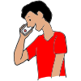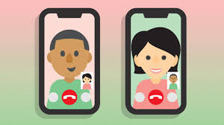
All of my friends have to stay at their homes. While we wait to see each other again, we can do work and have fun at home. I can hang out with my family. I might play games, do puzzles, or watch movies. When I go outside, I might see some of the people in my neighborhood. I can wave and say hi. I should not be too close to others, give high 5s, or give hugs. I could ride my bike or take a walk outside.
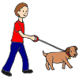
When it is safe for everyone to be together, I will be able to hang out with my friends again. I will be so happy to see my friends and they will be happy to see me!

